Stack
Data structure, items are pushed to the top of the stack
Popped off the top when deleted
Can peek at the top file, without deleting it
LAST IN FIRST OUT
Pushing an item onto a full stack creates an overflow
Popping nothing makes an underflow

Local variables are held on stacks

Queue, first in first out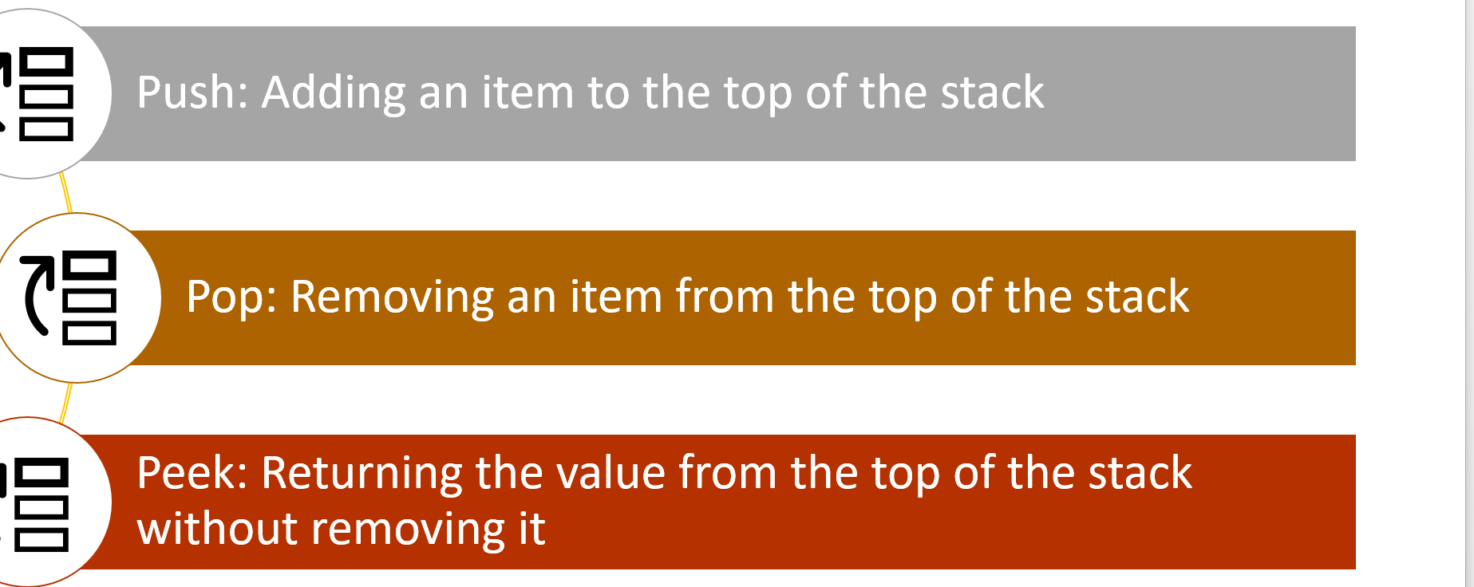

Linked list = data structure that provides a foundation for other structures
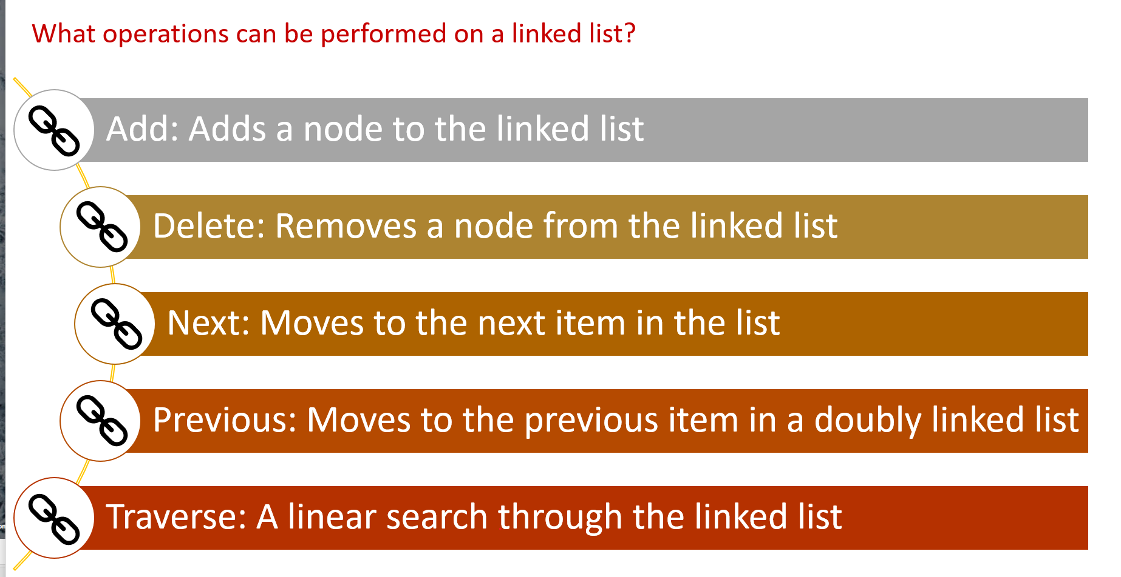
Adv: helps in memory management
Why? The data in primary memory is not contiguous
Depth is one by one randomly
Breadth is simultaneously
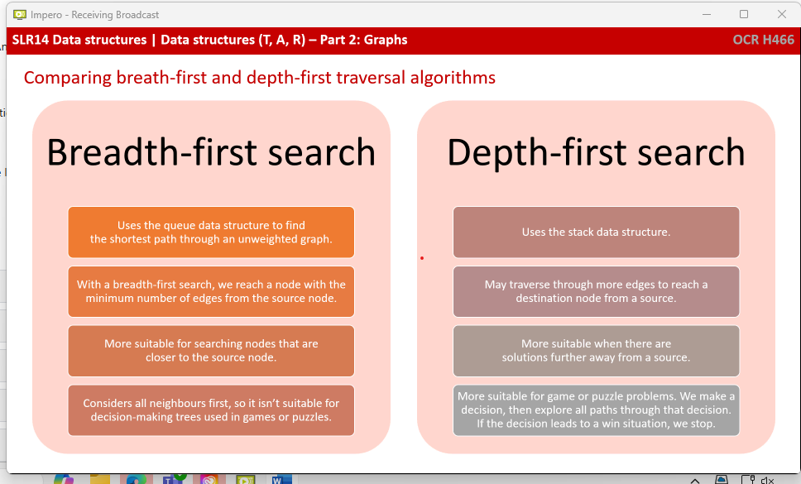
Trees:
A rooted tree has a node that’s designated as a root
Binary tree is a rooted tree with a max of 2 children per node
For binary, the first item is used as the root node
Items smaller than/ equal to the root are placed to the left
Items greater than are placed on the right
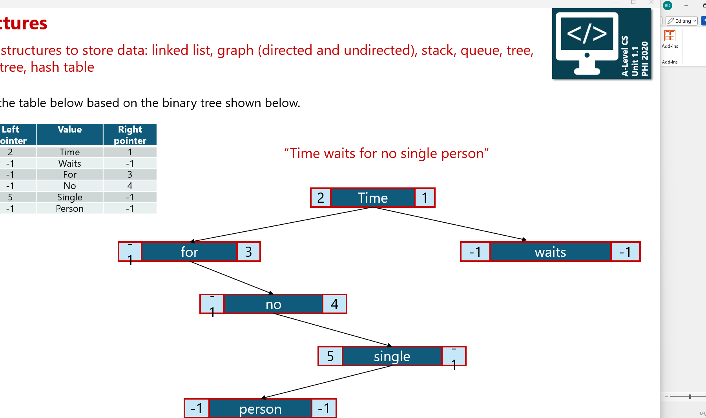
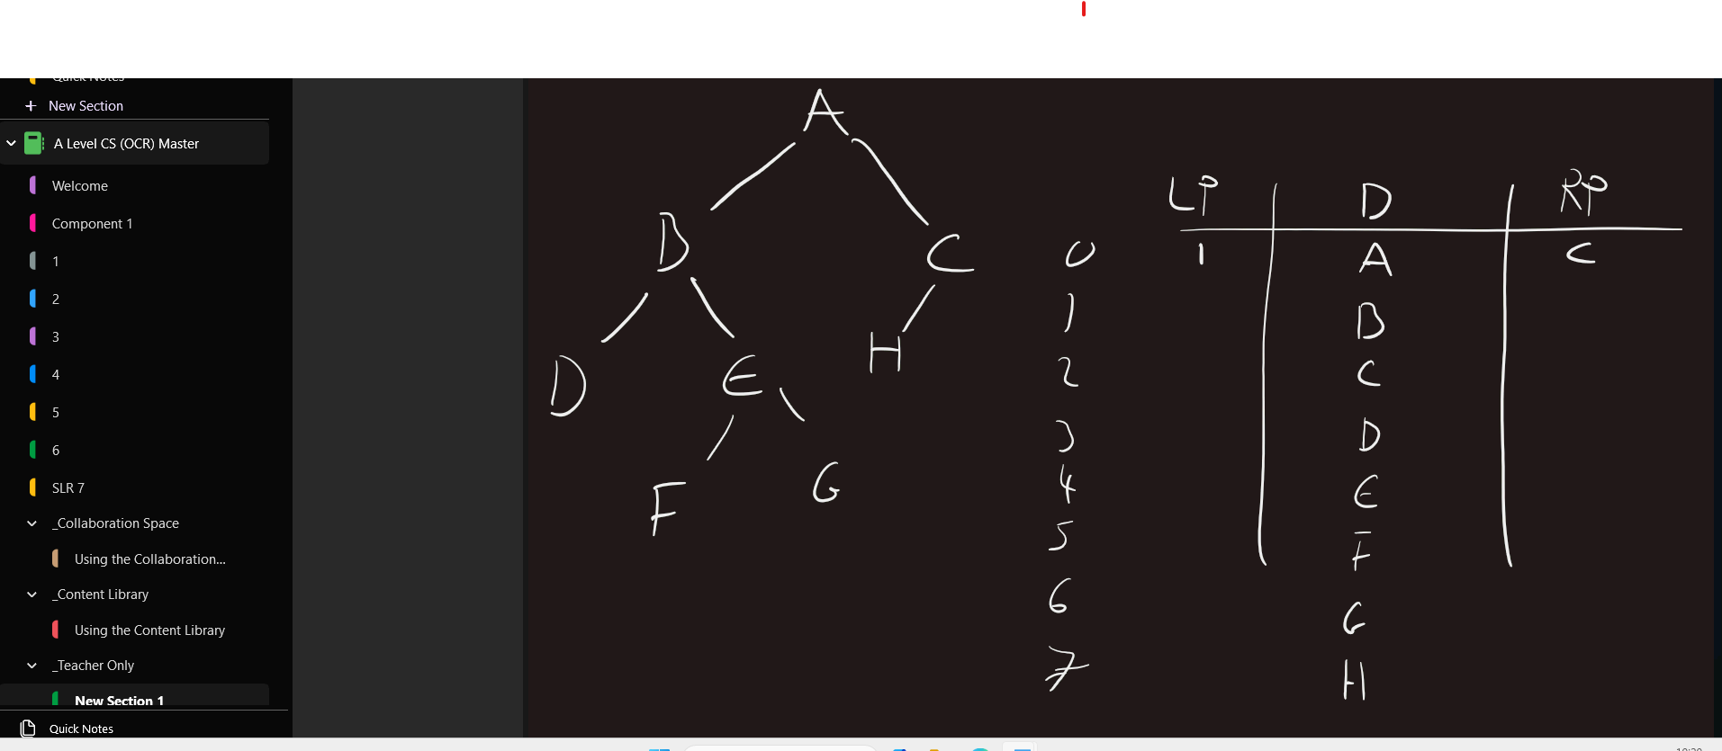
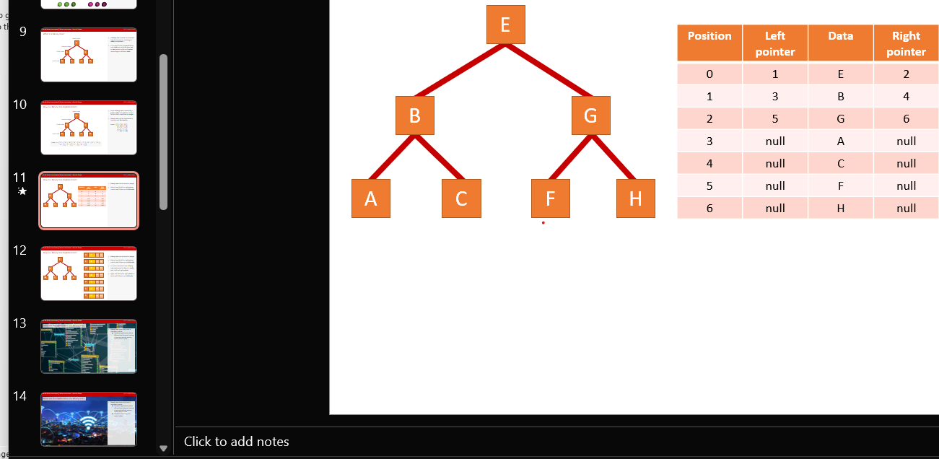
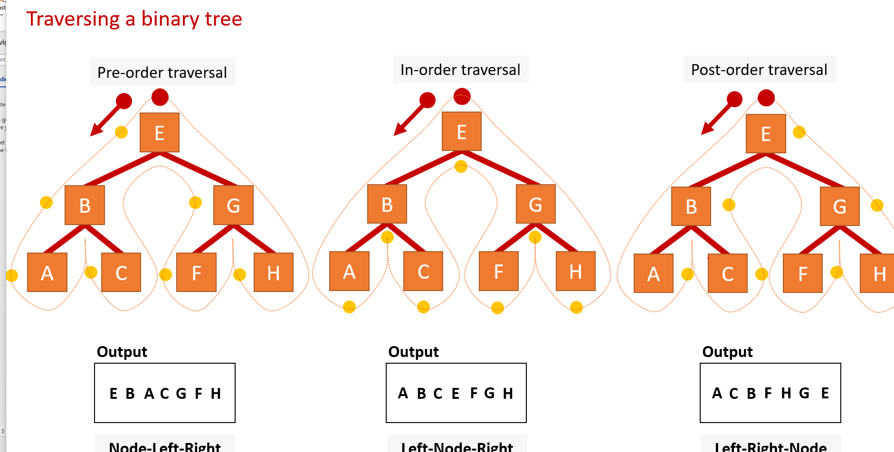
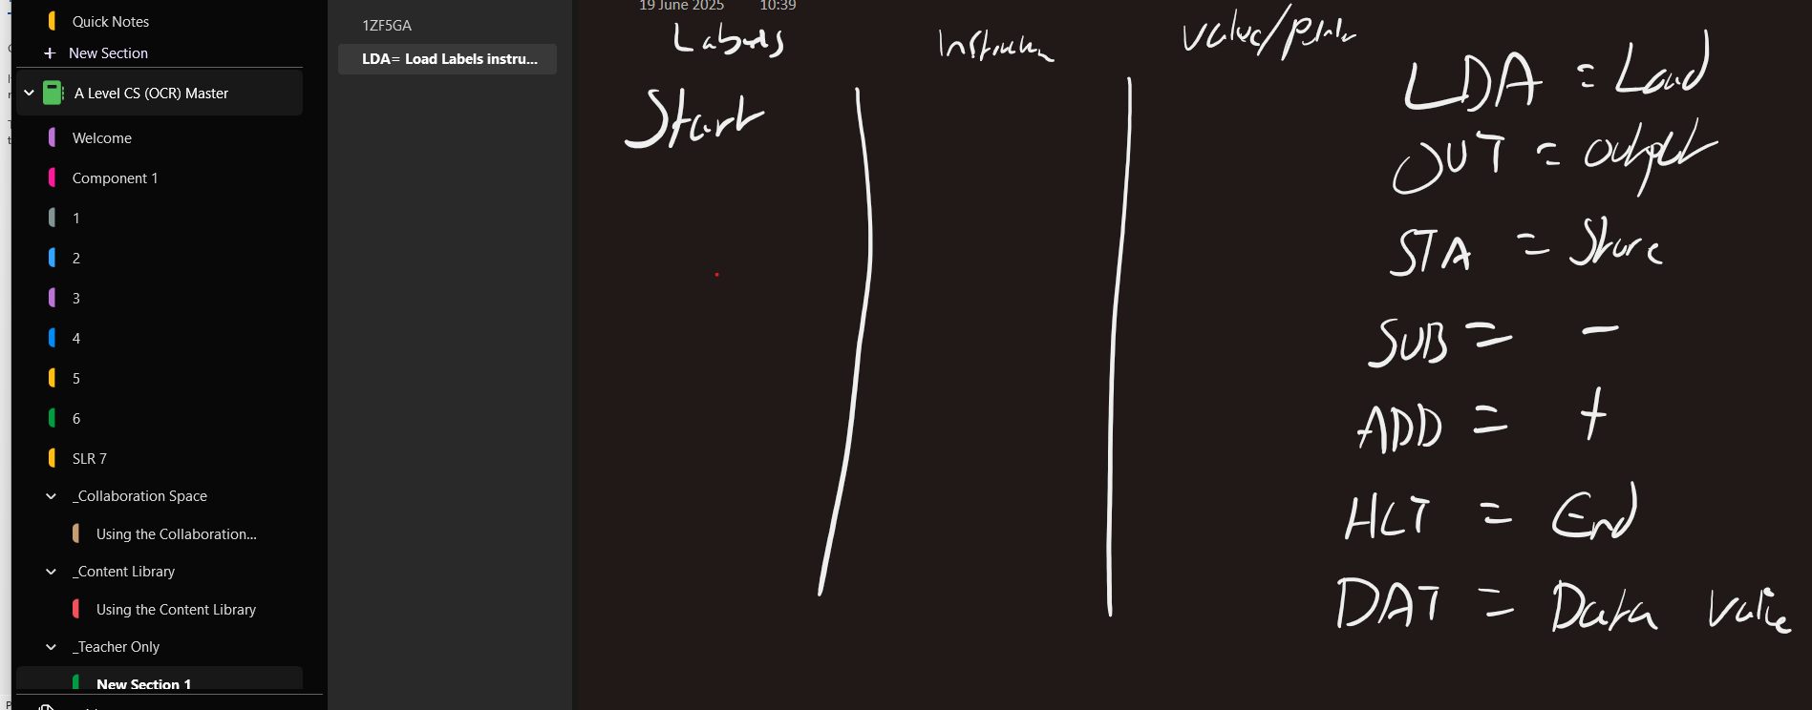

Hash tables:
Consist of an array and an associated hash function
The hash function takes a key and generates a hash value, used as an index in the array
If 2 leys produce the same hash value, a Collision occurs

